DATE: 21.08.2025

EXPERIMENT – 17 Change Hardware compatibility of a VM (Either by clone/create new one) which is already created and configured using vmware workstation.

Aim:

To change the hardware compatibility of an already created and configured VM using VMware Workstation.

Procedure:

1. Open VMware Workstation and select the VM whose hardware compatibility needs to be changed.
2. Ensure the VM is powered off.
3. Right-click on the VM → select Manage → Change Hardware Compatibility.
4. The Change Hardware Compatibility Wizard opens.
5. Select the desired VMware Workstation version for compatibility (e.g., Workstation 15.x, 16.x, etc.).
6. Choose whether to create a new clone of the VM or directly upgrade the existing one.
7. Review the settings and click Finish.
8. Once completed, start the VM to verify compatibility with the selected VMware version.

Output:

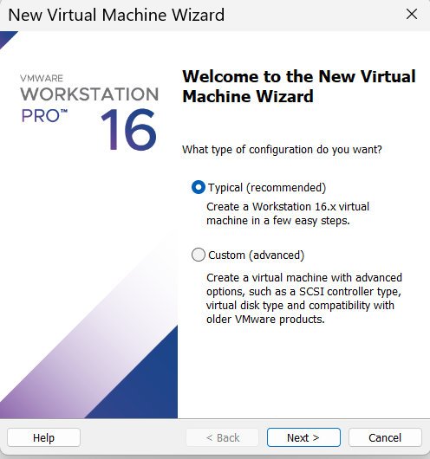

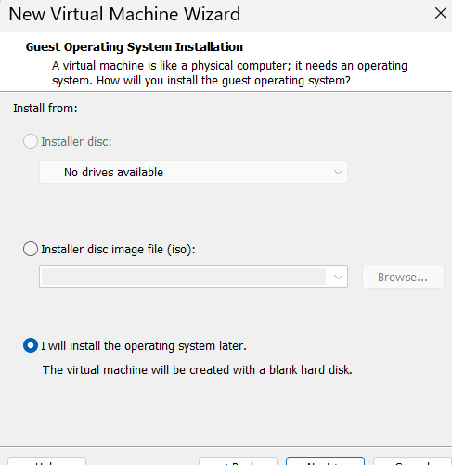

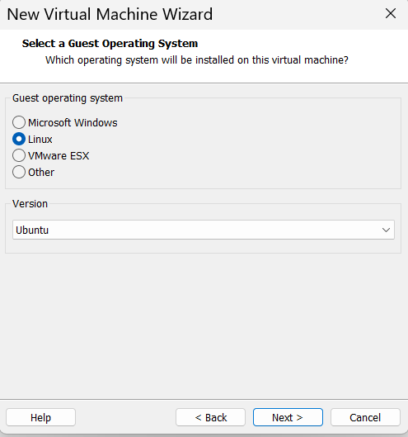

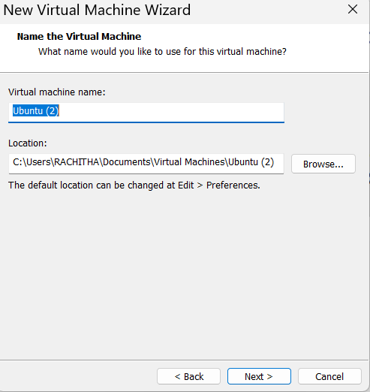

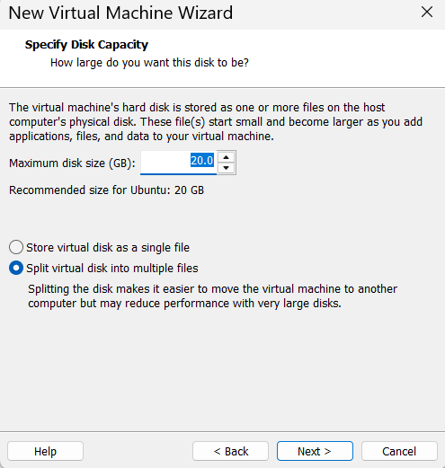

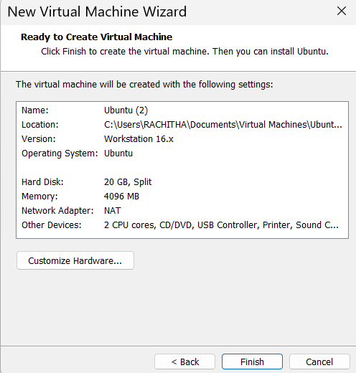

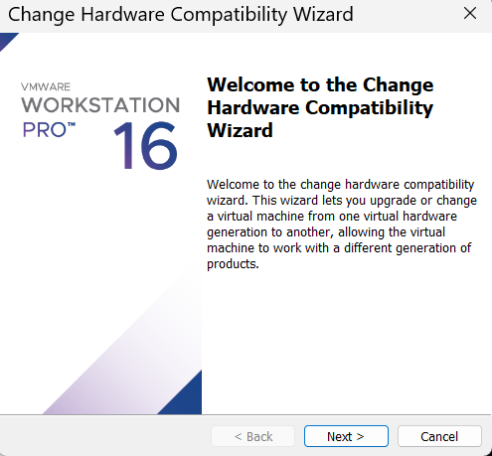

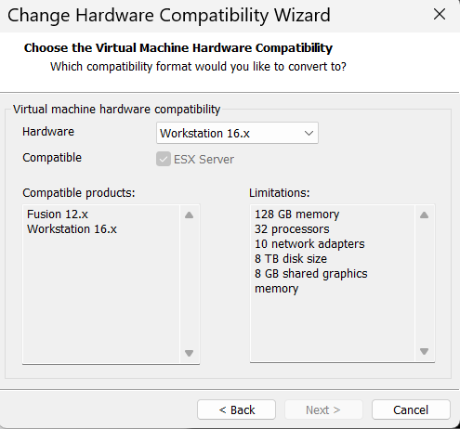

Result:

The hardware compatibility of the VM was successfully changed to the selected VMware Workstation version, and the VM operated correctly after the upgrade.